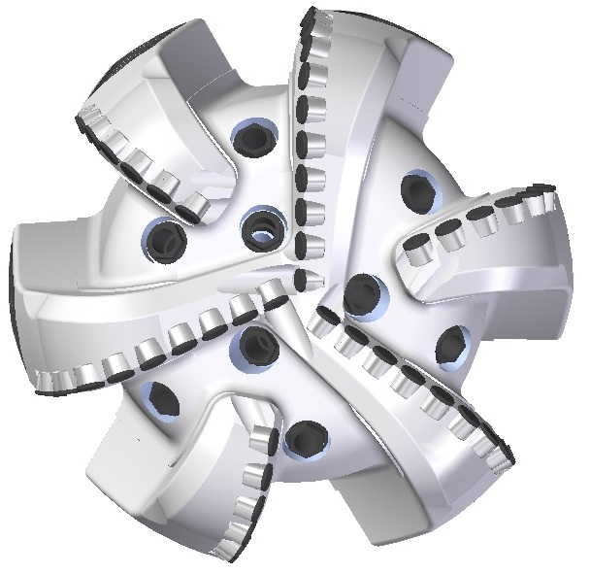 |  | 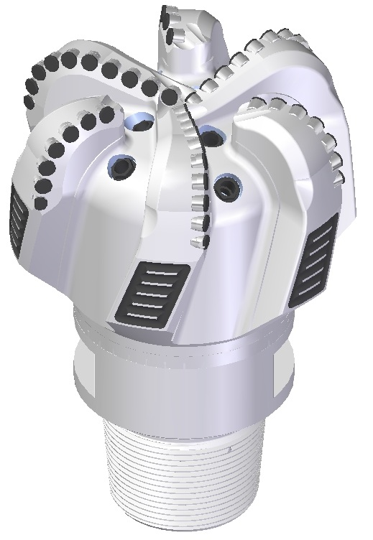

Drill Bit Specifications:
Cutter Size (Primary, Sec) | 5/8” , 1/2”
Cutter Count (Total, Gage) | 52 , 8
Blade Count | 6
Gage Length (Inches) | 3.00
Nozzle Count (Primary, Sec.) | 9
Nozzle Size (Primary, Sec.) | 60
JSA (Sq. Inches) | 35.53
Max. TFA (Sq. Inches) | 2.24
Operating Parameters:
Hydraulic Flow Rate (GPM) | 368 - 700
Max. Weight on Bit (1,000 Lbs.) | 47
Make-up Torque (ft/lbs) | 40,563
Nominal Dimensions:
Overall Length (Inches) | 17.875
Make Up Length (Inches) | 13.000
Bit Breaker | SKB-21011
Connection | Ø6-5/8" API Reg.
Approx. Weight (Lbs.) | 211

Standard Features:

- Large open face volume assists cuttings removal
- Nine nozzles optimize blade cleaning and cuttings removal
- Premium grade cutters maximize ROP and Life

616-SR9 Nomenclature Explained:

- 6 = Number of blades
- 16 = Primary Cutter Size (16mm)
- SR = Single Row of Cutters
- 9 = Number of nozzles
Interchangeable nozzles.

